**CHAPTER-I**

**INTRODUCTION**

**1.1 GENERAL BACKGROUND:**

The first grass cutter was invented by Edwin Budding in 1830 in Thrupp, just outside Stroud, in Gloucestershire, England. Budding's mower was designed primarily to cut the grass on sports grounds and extensive gardens, as a superior alternative to the scythe, and was granted a British patent on August 31,1830.Now a days there are lots of development work has peen pending but there are still some labor power which requires lots of income distribution for a small work. So this is required that some work should have some other alternative so that the labor power wastage can be avoided. So in our project we are trying to make a daily purpose robot which is able to cut the grasses in lawn. The project work will be done according to the proper application based fabrication. The system will have some automation work for guidance and other obstacle detection. The system will have a power source that is battery and a solar panel will be attached on the top of the robot. Moving the grass cutters with a standard motor powered grass cutters is an inconvenience, and no one takes pleasure in it. Cutting grass cannot be easily accomplished by elderly, younger, grass cutter moving with engine create noise pollution due to the loud engine, and local air pollution due to the combustion in the engine. Also, a motor powered engine requires periodic maintenance such as changing the engine oil. Even though electric solar grass are environmentally friendly, they too can be an inconvenience. Along with motor powered grass cutter, electric grass cutters are also hazardous and cannot be easily used by all. Also, if the electric grass cutter is corded, mowing could prove to be problematic and dangerous. The prototype will also be will be charged from sun by using solar panels.

**1.2 EMBEDDED SYSTEMS:**

Embedded systems are designed to do some specific task, rather than be a general-purpose computer for multiple tasks. Some also have real time performance constraints that must be met, for reason such as safety and usability; others may have low or no performance requirements, allowing the system hardware to be simplified to reduce costs.

An embedded system is not always a separate block - very often it is physically built-in to the device it is controlling. The software written for embedded systems is often called firmware, and is stored in read-only memory or flash convector chips rather than a disk drive. It often runs with limited computer hardware resources: small or no keyboard, screen, and little memory.Wireless communication has become an important feature for commercial products and a popular research topic within the last ten years. There are now more mobile phone subscriptions than wired-line subscriptions. Lately, one area of commercial interest has been low-cost, low-power, and short-distance wireless communication used for \personal wireless networks. Technology advancements are providing smaller and more cost effective devices for integrating computational processing, wireless communication, and a host of other functionalities.These embedded communications devices will be integrated into applications ranging from homeland security to industry automation and monitoring. They will also enable custom tailored engineering solutions, creating a revolutionary way of disseminating and processing information. With new technologies and devices come new business activities, and the need for employees in these technological areas. Engineers who have knowledge of embedded systems and wireless communications will be in high demand. Unfortunately, there are few adorable environments available for development and classroom use, so students often do not learn about these technologies during hands-on lab exercises. The communication mediums were twisted pair, optical fiber, infrared, and generally wireless radio.

**1.3 PROBLEM IDENTIFICATION:**

A Solar Grass Cutter is a machine that uses a revolving blade or blades to cut a lawn at an even height. Lawn mowers employing a blade that rotates about a vertical axis are known as rotary mowers, while those employing a blade assembly that rotates about a horizontal axis are known as cylinder or reel mowers. Many designs have been made, each suited to a particular purpose. The smallest types, pushed by a human, are suitable for small residential lawns and gardens, while larger, self-contained, ride-on mowers are suitable for large lawns, and the largest, multi-gang mowers pulled behind a tractor, are designed for large expanses of grass such as golf courses and municipal parks.The problems with available grass cutter robots

1. Power consumption:

The available grass cutter are petrochemical powered or electrical powered which will consume

large amount of conventional energy Source.

2. Human effort:

The mowing work always needs to get control with a worker for the proper mowing.

3. Time consumption:

For mowing the land in different patterns and design it takes larger time and human effort

**1.4 BLOCK DIAGRAM** 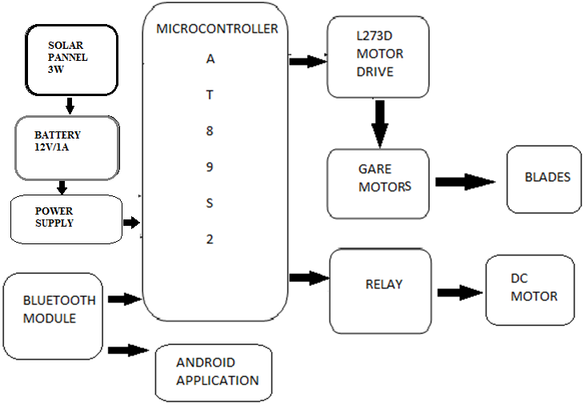

**Fig.no:1.1 block diagram of solar grass cutter by using android application**

**CHAPTER-II**

**INTRODUCTION TO 8052 MICROCONTROLLER**

**2.1 A BRIEF HISTORY OF 8052:**

In 1981, Intel Corporation introduced an 8 bit microcontroller called 8052. This microcontroller had 128 bytes of RAM, 4K bytes of chip ROM, two timers, one serial port, and four ports all on a single chip. At the time it was also referred as “A SYSTEM ON A CHIP”

**2.1.1AT89S52:**

The AT89S52 is a low-power, high-performance CMOS 8-bit microcontroller with 8K bytes of in-system programmable Flash memory. The device is manufactured using Atmel’s high-density nonvolatile memory technology and is compatible with the industry-standard 80C51 instruction set and pinout. The on-chip Flash allows the program memory to be reprogrammed in-system or by a conventional nonvolatile memory pro-grammer. By combining a versatile 8-bit CPU with in-system programmable Flash on a monolithic chip, the Atmel AT89S52 is a powerful microcontroller, which provides a highly flexible and cost-effective solution to many, embedded control applications. The AT89S52 provides the following standard features: 8K bytes of Flash, 256 bytes of RAM, 32 I/O lines, Watchdog timer, two data pointers, three 16-bit timer/counters, a six-vector two-level interrupt architecture, a full duplex serial port, on-chip oscillator, and clock circuitry. In addition, the AT89S52 is designed with static logic for operation down to zero frequency and supports two software selectable power saving modes. The Idle Mode stops the CPU while allowing the RAM, timer/counters, serial port, and interrupt system to continue functioning. The Power-down mode saves the RAM con-tents but freezes the oscillator, disabling all other chip functions until the next interrupt.

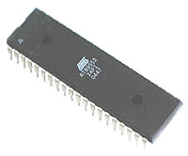

**Fig: 2.1 8052 Microcontroller**

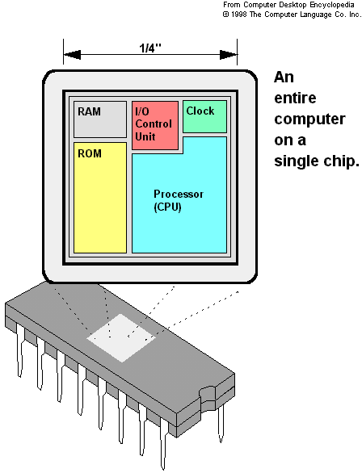

**Fig: 2.2 8052 Microcontroller Parts**

* + - 8031 128 bytes of RAM, two timers and 6 interrupts.
    - 8051 4K ROM, 128 bytes of RAM, two timers and 6 interrupts.
    - 8052 has 8K ROM, 256 bytes of RAM, three timers and 8 interrupts.

Of the three microcontrollers, 8052 is the most preferable. Microcontroller supports both serial and parallel communication. In the concerned project 8052 microcontroller is used. Here microcontroller used is AT89S52, which is manufactured by ATMEL laboratories.

The 8051 is the name of a big family of microcontrollers. The device which we are going to use along this tutorial is the **'**AT89S52**'** which is a typical 8051 microcontroller manufactured by Atmel™. Note that this part doesn't aim to explain the functioning of the different components .The block diagram provided by Atmel™ in their datasheet showing the architecture the 89S52 device can seem very complicated, and since we are going to use the C high level language to program it. This figures shows the main features and components that the designer can interact with you can notice that the 89S52 has 4 different ports, each one having 8 Input/output lines providing a total of 32 I/O lines. Those ports can be used to output DATA and orders do other devices, or to read the state of a sensor, or a switch. Most of the ports of the 89S52 have 'dual function' meaning that they can be used for two different functions: the first one is to perform input/output operations and the second one is used to implement special features of the microcontroller like counting external pulses, interrupting the execution of the program according to external events, performing serial data transfer or connecting the chip to a computer to update the software.

**2.2 NECESSITY OF MICROCONTROLLERS:**

Microprocessors brought the concept of programmable devices and made many applications of intelligent equipment. Most applications, which do not need large amount of data and program memory, tended to be costly. The microprocessor system had to satisfy the data and program requirements so, sufficient RAM and ROM are used to satisfy most applications .The peripheral control equipment also had to be satisfied. Therefore, almost all-peripheral chips were used in the design. Because of these additional peripherals cost will be comparatively high.

### An example:

8085 chip needs:

An Address latch for separating address from multiplex address and data. 32-KB RAM and 32-KB ROM to be able to satisfy most applications. As also Timer / Counter, Parallel programmable port, Serial port, and Interrupt controller are needed for its efficient applications. In comparison a typical Micro controller 8052 chip has all that the 8051 board has except a reduced memory as follows.

4K bytes of ROM as compared to 32-KB, 128 Bytes of RAM as compared to 32-KB.

**2.2.1 DEBUGGING:**

Lots of Microprocessor circuitry and program to debug. In Micro controller there is no Microprocessor circuitry to debug. Slower Development time: As we have observed Microprocessors need a lot of debugging at board level and at program level, whereas, Micro controller do not have the excessive circuitry and the built-in peripheral chips are easier to program for operation. So peripheral devices like Timer/Counter, Parallel programmable port, Serial Communication Port, Interrupt controller and so on, which were most often used were integrated with the Microprocessor to present the Micro controller .RAM and ROM also were integrated in the same chip. The ROM size was anything from 256 bytes to 32Kb or more. RAM was optimized to minimum of 64 bytes to 256 bytes or more.

Microprocessor has following instructions to perform:

1. Reading instructions or data from program memory ROM.
2. Interpreting the instruction and executing it.
3. Microprocessor Program is a collection of instructions stored in a Nonvolatile memory.
4. Read Data from I/O device
5. Process the input read, as per the instructions read in program memory.
6. Read or write data to Data memory.
7. Write data to I/O device and output the result of processing to O/P device.

**2.3 INTRODUCTION TO AT89S52:**

The system requirements and control specifications clearly rule out the use of 16, 32 or 64 bit micro controllers or microprocessors. Systems using these may be earlier to implement due to large number of internal features. They are also faster and more reliable but, the above application is satisfactorily served by 8-bit micro controller. Using an inexpensive 8-bit Microcontroller will doom the 32-bit product failure in any competitive market place. Coming to the question of why to use 89S52 of all the 8-bit Microcontroller available in the market the main answer would be because it has 8kB Flash and 256 bytes of data RAM32 I/O lines, three 16-bit timer/counters, a Eight-vector two-level interrupt architecture, a full duplex serial port, on-chip oscillator, and clock circuitry. In addition, the AT89S52 is designed with static logic for operation down to zero frequency and supports two software selectable power saving modes. The Idle Mode stops the CPU while allowing the RAM, timer/counters, serial port, and interrupt system to continue functioning. The Power Down Mode saves the RAM contents but freezes the oscillator, disabling all other chip functions until the next hardware reset. The Flash program memory supports both parallel programming and in Serial In-System Programming (ISP). The 89S52 is also In-Application Programmable (IAP), allowing the Flash program memory to be reconfigured even while the application is running.

By combining a versatile 8-bit CPU with Flash on a monolithic chip, the Atmel AT89S52 is a powerful microcomputer which provides a highly flexible and cost effective solution to many embedded control applications.

**2.3.1FEATURES:**

* Compatible with MCS-51 Products
* 8K Bytes of In-System Reprogrammable Flash Memory
* Fully Static Operation: 0 Hz to 33 MHz
* Three-level Program Memory Lock
* 256 x 8-bit Internal RAM
* 32 Programmable I/O Lines
* Three 16-bit Timer/Counters
* Eight Interrupt Sources
* Programmable Serial Channel
* Low-power Idle and Power-down Modes
* 4.0V to 5.5V Operating Range
* Full Duplex UART Serial Channel
* Interrupt Recovery from Power-down Mode
* Watchdog Timer
* Dual Data Pointer
* Power-off Flag
* Fast Programming Time
* Flexible ISP Programming (Byte and Page Mode)

**2.4 PIN DIAGRAM:**

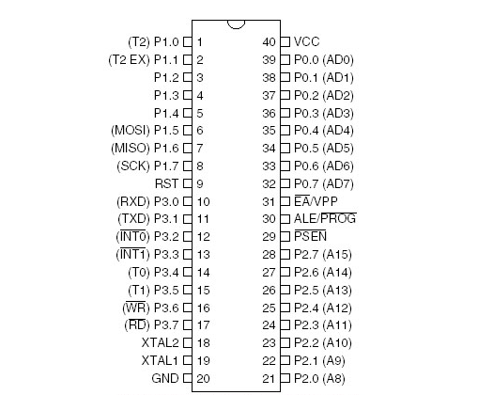

**Fig: 2.3 Pin Diagram Of 8052 Ic**

**2.4.1 PIN DESCRIPTION:**

**1. VCC:**

Supply voltage.

**2. GND:**

Ground.

**3. Port 0:**

Port 0 is an 8-bit open drain bidirectional I/O port. As an output port, each pin can sink eight TTL inputs. When 1sare written to port 0 pins, the pins can be used as highimpedanceinputs Port 0 can also be configured to be the multiplexed loworderaddress/data bus during accesses to external program and data memory. In this mode, P0 has internalpullups.Port 0 also receives the code bytes during Flash programming and outputs the code bytes during program verification. External pull-ups are required during program verification.

**4. Port 1:**

Port 1 is an 8-bit bidirectional I/O port with internal pullups.The Port 1 output buffers can sink/source four TTL inputs. When 1s are written to Port 1 pins, they are pulled high by the internal pull-ups and can be used as inputs. As inputs Port 1 pins that are externally being pulled low will source current (IIL) because of the internal pullups.In addition, P1.0 and P1.1 can be configured to be the timer/counter 2 external count input (P1.0/T2) and the timer/counter 2 trigger input (P1.1/T2EX), respectively, as shown in the following table. Port 1 also receives the low-order address bytes during Flash programming and verification.

**5.Port 2:**

Port 2 is an 8-bit bidirectional I/O port with internal pullups.The Port 2 output buffers can sink/source four TTL inputs. When 1s are written to Port 2 pins, they are pulled high by the internal pull-ups and can be used as inputs. As inputs, Port 2 pins that are externally being pulled low will sourcecurrent (IIL) because of the internal pullups.Port 2 emits the high-order address byte during fetches from external program memory and during accesses to external data memory that use 16-bit addresses (MOVX @DPTR). In this application, Port 2 uses strong internal pull-ups when emitting 1s. During accesses to external data memory that use 8-bit addresses (MOVX @ RI), Port 2emits the contents of the P2 Special Function Register. Port 2 also receives the high-order address bits and some control signals during Flash programming and verification.

**6. Port 3:**

Port 3 is an 8-bit bidirectional I/O port with internal pullups.The Port 3 output buffers can sink/source four TTL inputs. When 1s are written to Port 3 pins, they are pulled high by the internal pull-ups and can be used as inputs. As inputs, Port 3 pins that are externally being pulled low will source current (IIL) because of the pullups.Port 3 also serves the functions of various special features of the AT89S52, as shown in the following table. Port 3 also receives some control signals for Flash programming and verification.

**7. RST:**

Reset input. A high on this pin for two machine cycles while the oscillator is running resets the device. This pin drives High for 96 oscillator periods after the Watchdog times out. The DISRTO bit in SFR AUXR (address 8EH) can be usedto disable this feature. In the default state of bit DISRTO,the RESET HIGH out feature is enabled.**ALE/PROG** Address Latch Enable (ALE) is an output pulse for latching the low byte of the address during accesses to external memory. This pin is also the program pulse input (PROG) during Flash programming. In normal operation, ALE is emitted at a constant rate of1/6 the oscillator frequency and may be used for external timing or clocking purposes. Note, however, that one ALE pulse is skipped during each access to external data memory.

If desired, ALE operation can be disabled by setting bit 0 offs locations 8EH. With the bit set, ALE is active only during MOVX or MOVC instruction. Otherwise, the pin is weakly pulled high. Setting the ALE-disable bit has no effect if the microcontroller is in external execution mode.

**8. PSEN:**

Program Store Enable (PSEN) is the read strobe to external program memory. When the AT89S52 is executing code from external program memory, PSEN is activated twice each machine cycle, except that two PSEN activations are skipped during each access to external data memory.

**9.EA/VPP:**

External Access Enable. EA must be strapped to GND in order to enable the device to fetch code from external program memory locations starting at 0000H up to FFFFH.Note, however, that if lock bit 1 is programmed, EA will be internally latched on reset. A should be strapped to VCC for internal program executions. This pin also receives the 12-volt programming enable voltage**.**(VPP) during Flash programming.

**10. XTAL1:**

Input to the inverting oscillator amplifier and input to the internal clock operating circuit.

**11. XTAL2:**

Output from the inverting oscillator amplifier.

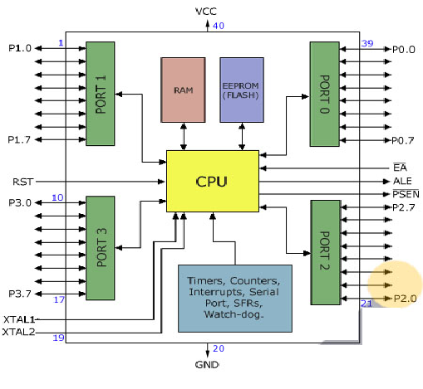

**Fig: 2.4 Functional Block Diagram Of 8052 Micro Controller.**

**2.5. THE 8052 OSCILLATOR AND CLOCK**:

The heart of the 8051 circuitry that generates the clock pulses by which all the internal all internal operations are synchronized. Pins XTAL1 And XTAL2 is provided for connecting a resonant network to form an oscillator. Typically a quartz crystal and capacitors are employed. The crystal frequency is the basic internal clock frequency of the microcontroller. The manufacturers make 8051 designs that run at specific minimum and maximum frequencies typically 1 to 16 MHz.

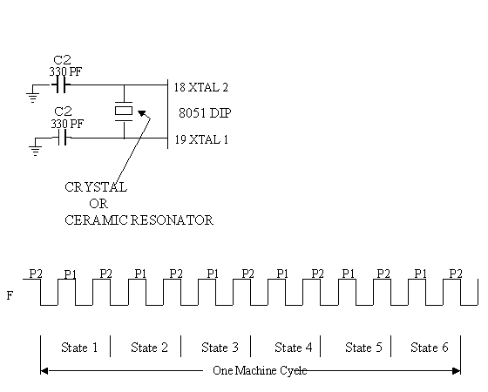

**Fig:2.5 Oscillator And Timing Circuit**

**CHAPTER-III**

**MEMORY MANAGEMENTSYSTEM**

**3.1 TYPES OF MEMORY:**

The 8052 have three general types of memory. They are on-chip memory, external Code memory and external Ram. On-Chip memory refers to physically existing memory on the micro controller itself. External code memory is the code memory that resides off chip. This is often in the form of an external EPROM. External RAM is the Ram that resides off chip. This often is in the form of standard static RAM or flash RAM.

**1)Code Memory:**

Code memory is the memory that holds the actual 8052 programs that is to be run. This memory is limited to 64K. Code memory may be found on-chip or off-chip. It is possible to have 8K of code memory on-chip and 60K off chip memory simultaneously. If only off-chip memory is available then there can be 64K of off chip ROM. This is controlled by pin provided as EA

**2)Internal Ram:**

The 8052 have a bank of 256 bytes of internal RAM. The internal RAM is found on-chip. So it is the fastest Ram available. And also it is most flexible in terms of reading and writing. Internal Ram is volatile, so when 8051 is reset, this memory is cleared. 256 bytes of internal memory are subdivided. The first 32 bytes are divided into 4 register banks. Each bank contains 8 registers. Internal RAM also contains 256 bits, which are addressed from 20h to 2Fh. These bits are bit addressed i.e. each individual bit of a byte can be addressed by the user. They are numbered 00h to FFh. The user may make use of these variables with commands such as SETB and CLR.

**3.2 SPECIAL FUNCTION REGISTERED MEMORY:**

Special function registers are the areas of memory that control specific functionality of the 8052 micro controller.

**a) Accumulator (0E0h):**

As its name suggests, it is used to accumulate the results of large no of instructions. It can hold 8 bit values.

**b) B Registers (0f0h):**

The B register is very similar to accumulator. It may hold 8-bit value. The b register is only used by MUL AB and DIV AB instructions. In MUL AB the higher byte of the product gets stored in B register. In div AB the quotient gets stored in B with the remainder.

**c) Stack Pointer (81h):**

The stack pointer holds 8-bit value. This is used to indicate where thenext value to be removed from the stack should be taken from. When a value is to be pushed onto the stack, the 8052 first store the value of SP and then store the value at the resulting memory location. When a value is to be popped from the stack, the 8052 returns the value from the memory location indicated by SP and then decrements the value of SP.

**d) Data Pointer:**

The SFRs DPL and DPH work together work together to represent a 16-bit value called the data pointer. The data pointer is used in operations regarding external RAM and some instructions code memory. It is a 16-bit SFR and also an addressable SFR.

**e) Program Counter:**

The program counter is a 16 bit register, which contains the 2 byte address, which tells the 8052 where the next instruction to execute to be found in memory. When the 8052 is initialized PC starts at 0000h. And is incremented each time an instruction is executes. It is not addressable SFR.

**f) PCON (Power Control, 87h):**

The power control SFR is used to control the 8051’s power control modes. Certain operation modes of the 8051 allow the 8051 to go into a type of “sleep mode” which consumes much lee power.

**g) TCON (Timer Control, 88h)**

The timer control SFR is used to configure and modify the way in which the 8051’s two timers operate. This SFR controls whether each of the two timers is running or stopped and contains a flag to indicate that each timer has overflowed. Additionally, some non-timer related bits are located in TCON SFR. These bits are used to configure the way in which the external interrupt flags are activated, which are set when an external interrupt occurs.

**h) TMOD (Timer Mode, 89h):**

The timer mode SFR is used to configure the mode of operation of each of the two timers. Using this SFR your program may configure each timer to be a 16-bit timer, or 13 bit timer, 8-bit auto reload timer, or two separate timers. Additionally you may configure the timers to only count when an external pin is activated or to count “events” that are indicated on an external pin.

**i) TO (Timer 0 Low/High, Address 8A/8C h):**

These two SFRs taken together represent timer 0. Their exact behavior depends on how the timer is configured in the TMOD SFR; however, these timers always count up. What is configurable is how and when they increment in value.

**j) T1 (Timer 1 Low/High, Address 8B/ 8D H):**

These two SFRs, taken together, represent timer 1. Their exact behavior depends on how the timer is configured in the TMOD SFR; however, these timers always count up.

**k) P0 (Port 0, Address 90h, Bit Addressable**)**:**

This is port 0 latch. Each bit of this SFR corresponds to one of the pins on a micro controller. Any data to be outputted to port 0 is first written on P0 register. For e.g., bit 0 of port 0 is pin P0.0, bit 7 is pin p0.7. Writing a value of 1 to a bit of this SFR will send a high level on the corresponding I/O pin whereas a value of 0 will bring it to low level.

**l) P1 (Port 1, Address 90h, Bit Addressable):**

This is port latch1. Each bit of this SFR corresponds to one of the pins on a micro controller. Any data to be outputted to port 0 is first written on P0 register. For e.g., bit 0 of port 0 is pin P1.0, bit 7 is pin P1.7. Writing a value of 1 to a bit of this SFR will send a high level on the corresponding I/O pin whereas a value of 0 will bring it to low level

**m) P2 (Port 2, Address 0a0h, Bit Addressable):**

This is a port latch2. Each bit of this SFR corresponds to one of the pins on a micro controller. Any data to be outputted to port 0 is first written on P0 register. For e.g., bit 0 of port 0 is pin P2.0, bit 7 is pin P2.7. Writing a value of 1 to a bit of this SFR will send a high level on the corresponding I/O pin whereas a value of 0 will bring it to low level.

**n) P3 (Port 3, Address B0h, Bit Addressable):**

This is a port latch3. Each bit of this SFR corresponds to one of the pins on a micro controller. Any data to be outputted to port 0 is first written on P0 register. For e.g., bit 0 of port 0 is pin P3.0, bit 7 is pin P3.7. Writing a value of 1 to a bit of this SFR will send a high level on the corresponding I/O pin whereas a value of 0 will bring it to low level.

**o) IE (Interrupt Enable, 0a8h):**

The Interrupt Enable SFR is used to enable and disable specific interrupts. The low 7 bits of the SFR are used to enable/disable the specific interrupts, where the MSB bit is used to enable or disable all the interrupts. Thus, if the high bit of IE is 0 all interrupts are disabled regardless of whether an individual interrupt is enabled by setting a lower bit.

**p) IP (Interrupt Priority, 0b8h):**

The interrupt priority SFR is used to specify the relative priority of each interrupt. On 8051, an interrupt maybe either low or high priority. An interrupt may interrupt interrupts. For e.g., if we configure all interrupts as low priority other than serial interrupt. The serial interrupt always interrupts the system, even if another interrupt is currently executing. However, if a serial interrupt is executing no other interrupt will be able to interrupt the serial interrupt routine since the serial interrupt routine has the highest priority.

**q) PSW (Program Status Word, 0d0h**)**:**

The program Status Word is used to store a number of important bits that are set and cleared by 8052 instructions. The PSW SFR contains the carry flag, the auxiliary carry flag, the parity flag and the overflow flag. Additionally, it also contains the register bank select flags, which are used to select, which of the “R” register banks currently in use.

**r) SBUF (Serial Buffer, 99h):**

SBUF is used to hold data in serial communication. It is physically two registers. One is writing only and is used to hold data to be transmitted out of 8052 via TXD. The other is read only and holds received data from external sources via RXD. Both mutually exclusive registers use address 99h.

**CHAPTER-IV**

**POWER SUPPLY**

**4.1 REGULATED POWER SUPPY:**

All digital circuits require regulated power supply. In this article we are going to learn how to get a regulated positive supply from the mains supply.

**4.1.1 FILTER CAPACITOR:**

Even though half wave & full wave rectifier give DC output, none of them provides a constant output voltage. For this we require to smoothen the waveform received from the rectifier. This can be done by using a capacitor at the output of the rectifier this capacitor is also called as “FILTER CAPACITOR” or “SMOOTHING CAPACITOR” or “RESERVOIR CAPACITOR”. Even after using this capacitor a small amount of ripple will remain.We place the Filter Capacitor at the output of the rectifier the capacitor will charge to the peak voltage during each half cycle then will discharge its stored energy slowly through the load while the rectified voltage drops to zero, thus trying to keep the voltage as constant as possible.

If we go on increasing the value of the filter capacitor then the Ripple will decrease. But then

the costing will increase. The value of the Filter capacitor depends on the current consumed by

the circuit, the frequency of the waveform & the accepted ripple.

Where,

Vr = accepted ripple voltage ( should not be more than 10% of  the voltage)

I= current consumed by the circuit in Amperes.

F= frequency of the waveform. A half wave rectifier has only one peak in one cycle so F=25hz

Whereas a full wave rectifier has Two peaks in one cycle so F=100hz.

**4.1.2 VOLTAGE REGULATOR:**

A Voltage regulator is a device which converts varying input voltage into a constant regulated output voltage. Voltage regulator can be of two types

**1)  Linear Voltage Regulator:**

      Also called as Resistive Voltage regulator because they dissipate the excessive voltage resistively as heat.

**2)  Switching Regulators**:

They regulate the output voltage by switching the Current ON/OFF very rapidly. Since their output is either ON or OFF it dissipates very low power thus achieving higher efficiency as compared to linear voltage regulators. But they are more complex & generate high noise due to their switching action. For low level of output power switching regulators tend to be costly but for higher output wattage they are much cheaper than linear regulators.

The most commonly available Linear Positive Voltage Regulators are the 78XX series where the XX indicates the output voltage. And 79XX series is for Negative Voltage Regulators.

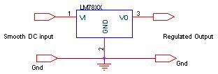

**Fig :4.1 Switching Regulator**

 After filtering the rectifier output the signal is given to a voltage regulator. The maximum input voltage that can be applied at the input is 35V.Normally there is a 2-3 Volts drop across the regulator so the input voltage should be at least 2-3 Volts higher than the output voltage. If the input voltage gets below the Vmin of the regulator due to the ripple voltage or due to any other reason the voltage regulator will not be able to produce the correct regulated voltage.

#### CHAPTER-V

#### WORKING OF GEAR MOTOR

**5.1.**GEAR MOTOR:

Gear motors are complete motive force systems consisting of an electric motor and a reduction gear train integrated into one easy-to-mount and -configure package. This greatly reduces the complexity and cost of designing and constructing power tools, machines and appliances calling for high torque at relatively low shaft speed or RPM. Gear motors allow the use of economical low-horsepower motors to provide great motive force at low speed such as in lifts, winches, medical tables, jacks and robotics. They can be large enough to lift a building or small enough to drive a tiny clock.

.[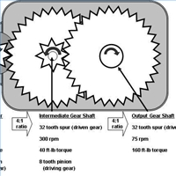](http://i.ehow.com/images/a05/24/jr/gear-motor-800X800.jpg)

**Fig:5.1 Gears Inside The Motor**

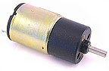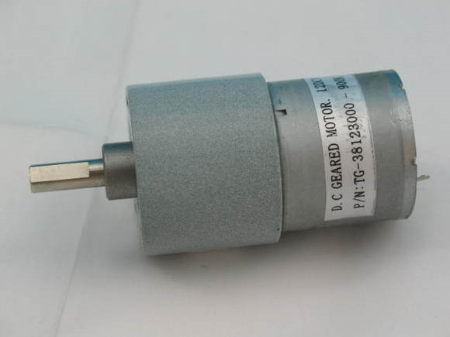

**Fig-5.2 12v High Torque Dc Gear Moto**r

**5.3.1 OPERATION PRINCIPLE:**

Most synchronous AC electric motors have output ranges of from 1,200 to 3,600 revolutions per minute. They also have both normal speed and stall-speed torque specifications. The reduction gear trains used in gear motors are designed to reduce the output speed while increasing the torque. The increase in torque is inversely proportional to the reduction in speed. Reduction gearing allows small electric motors to move large driven loads, although more slowly than larger electric motors. Reduction gears consist of a small gear driving a larger gear. There may be several sets of these reduction gear sets in a reduction gear box.

The four main objectives of gear motor are:

**1.Gear:**

# Toothed wheel that transmits the turning movement of one shaft to another shaft. Gear wheels may be used in pairs or in threes if both shafts are to turn in the same direction. The gear ratio – the ratio of the number of teeth on the two wheels – determines the torque ratio, the turning force on the output shaft compared with the turning force on the input shaft. The ratio of the angular velocities of the shafts is the inverse of the gear ratio.

The common type of gear for parallel shafts is the **spur gear**, with straight teeth parallel to the shaft axis. The **helical gear** has teeth cut along sections of a helix or corkscrew shape; the double form of the helix gear is the most efficient for energy transfer. **Bevel gears**, with tapering teeth set on the base of a cone, are used to connect intersecting shafts.

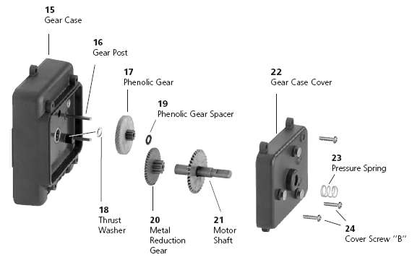

[](javascript:hil('3453n016.jpg'))

**Fig-5.3 Parts Inside Gear Motor**

The toothed and interlocking wheels which make up a typical gear movement.Gear ratio is calculated by dividing the number of teeth on the driver gear by the number of teeth on the driven gear (gear ratio = driver/driven); the idler gears are ignored. Idler gears change the direction of rotation but do not affect speed. A high driven to driver ratio (middle) is a speed-reducing ratio.Different gears are used to perform different engineering functions depending on the change in direction of motion that is needed. Rack and pinion gears are the commonest gears and are used in car steering mechanics.

**2.Speed Reduction:**

Sometimes the goal of using a gear motor is to reduce the rotating shaft speed of a motor in the device being driven, such as in a small electric clock where the tiny synchronous motor may be spinning at 1,200 rpm but is reduced to one rpm to drive the second hand, and further reduced in the clock mechanism to drive the minute and hour hands. Here the amount of driving force is irrelevant as long as it is sufficient to overcome the frictional effects of the clock mechanism.

**3.Torque Multiplication:**

Another goal achievable with a gear motor is to use a small motor to generate a very large force albeit at a low speed. These applications include the lifting mechanisms on hospital beds, power recliners, and heavy machine lifts where the great force at low speed is the goal.

**4.Motor Varieties:**

Most industrial gear motors are AC-powered, fixed-speed devices, although there are fixed-gear-ratio, variable-speed motors that provide a greater degree of control. DC gear motors are used primarily in automotive applications such as power winches on trucks, windshield wiper motors and power seat or power window motors.

**5.4 APPLICATIONS:**

What power can openers, garage door openers, stair lifts, rotisserie motors, timer cycle knobs on washing machines, power drills, cake mixers and electromechanical clocks have in common is that they all use various integrations of gear motors to derive a large force from a relatively small electric motor at a manageable speed. In industry, gear motor applications in jacks, cranes, lifts, clamping, robotics, conveyance and mixing are too numerous to count.

**CHAPTER-VI**

**SOLAR PANALS AND BLUETOOTH DEVICE**

**6.1 The SOLAR SYSTEM:**

It the gravitationally bound system comprising the [Sun](https://en.wikipedia.org/wiki/Sun) and the objects that orbit it, either directly or indirectly. Of those objects that orbit the Sun directly, the largest eight are the planet swith the remainder being smaller objects, such as dwarf planets and small Solar System bodies. Of the objects that orbit the Sun indirectly, the moons, two are larger than the smallest planet, Mercury.

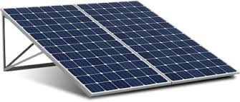

**Fig: 6.1 Solar Panel**

The Solar System formed 4.6 billion years ago from the gravitational collapse of a giant interstellar molecular cloud. The vast majority of the system's mass is in the Sun, with the majority of the remaining mass contained in Jupiter. The four smaller inner planets, Mercury, Venus, Earth and Mars, are terrestrial planets, being primarily composed of rock and metal. The four outer planets are giant planets, being substantially more massive than the terrestrials. The two largest, Jupiter and Saturn, are gas giants, being composed mainly of hydrogen and helium,the two outermost lanets, Uranus and Neptune, are ice giants, being composed mostly of substances with relatively high melting points compared, such as water, ammonia and methane. All eight planets have almost circular orbits that lie within a nearly flat disc called the ecliptic.

The Solar System also contains smaller objects.] The asteroid belt, which lies between the orbits of Mars and Jupiter, mostly contains objects composed, like the terrestrial planets, of rock and metal. Beyond Neptune's orbit lie the Kui per belt and scattered disc, which are populations of trans-Neptunian objects composed mostly of ices, and beyond them a newly discovered population of [sednoids](https://en.wikipedia.org/wiki/Sednoid). Within these populations are several dozen to possibly tens of thousands of objects large enough that they have been rounded by their own gravity.[]](https://en.wikipedia.org/wiki/Solar_System#cite_note-Stern2012-15) Such objects are categorized as dwarf planets. Identified dwarf planets include the asteroid Ceres  objects Pluto and Eris.,including comets, centaurs and interplanetary dust clouds, freely travel between regions. Six of the planets, at least four of the dwarf planets, and many of the smaller bodies are orbited by natural satellites,[[f]](https://en.wikipedia.org/wiki/Solar_System#cite_note-16) usually termed "moons" after the Moon. Each of the outer planets is encircled by planetary rings of dust and other small objects. The distance from Earth to the Sun is 1 astronomical unit (150,000,000 km), or AU. For comparison, the radius of the Sun is 0.0047 AU (700,000 km). Thus, the Sun occupies 0.00001% (10−5 %) of the volume of a sphere with a radius the size of Earth's orbit, whereas Earth's volume is roughly one millionth (10−6) that of the Sun. Jupiter, the largest planet, is 5.2 astronomical units (780,000,000 km) from the Sun and has a radius of 71,000 km (0.00047 AU), whereas the most distant planet, Neptune, is 30 AU (4.5×109 km) from the Sun.

With a few exceptions, the farther a planet or belt is from the Sun, the larger the distance between its orbit and the orbit of the next nearer object to the Sun. For example, Venus is approximately 0.33 AU farther out from the Sun than Mercury, whereas Saturn is 4.3 AU out from Jupiter, and Neptune lies 10.5 AU out from Uranus. Attempts have been made to determine a relationship between these orbital distances (for example, the Titius–Bode law),[32] but no such theory has been accepted. The images at the beginning of this section show the orbits of the various constituents of the Solar System on different scales.

Some Solar System models attempt to convey the relative scales involved in the Solar System on human terms. Some are small in scale (and may be mechanical—called [orreries](https://en.wikipedia.org/wiki/Orrery))—whereas others extend across cities or regional areas. The largest such scale model, the Sweden Solar System, uses the 110-metre (361-ft) Ericsson Globe in Stockholm as its substitute Sun, and, following the scale, Jupiter is a 7.5-metre (25-foot) sphere at Arlanda International Airport, 40 km (25 mi) away, whereas the farthest current object, [Sedna](https://en.wikipedia.org/wiki/90377_Sedna), is a 10-cm (4-in) sphere in [Luleå](https://en.wikipedia.org/wiki/Lule%C3%A5), 912 km (567 mi) away.The Solar System formed 4.568 billion years ago from the gravitational collapse of a region within a large molecular cloud. This initial cloud was likely several light-years across and probably birthed several stars. As is typical of molecular clouds, this one consisted mostly of hydrogen, with some helium, and small amounts of heavier elements fused by previous generations of stars. As the region that would become the Solar System, known as the pre-solar nebula collapsed, conservation of angular momentum caused it to rotate faster. The centre, where most of the mass collected, became increasingly hotter than the surrounding disc

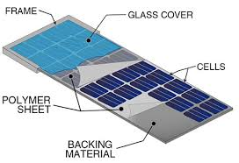

**Fig: 6.2 Solar Panel Parts**

As the contracting nebula rotated faster, it began to flatten into a protoplanetary disc with a diameter of roughly 200 [AU](https://en.wikipedia.org/wiki/Astronomical_unit)and a hot, dense proto star at the centre [41] The planets formed by accretion from this disc, in which dust and gas gravitationally attracted each other, coalescing to form ever larger bodies. Hundreds of protoplanets may have existed in the early Solar System, but they either merged or were destroyed, leaving the planets, dwarf planets, and leftover minor bodies.

**6.2 BLUETOOTH:**

It a wireless technology standard for exchanging data over short distances (using short-wavelength UHF radio waves in the ISM band from 2.4 to 2.485 GHz from fixed and mobile devices, and building personal area networks (PANs). Invented by telecom vendor Ericsson in 1994, it was originally conceived as a wireless alternative to RS-232 data cables.Bluetooth is managed by the Bluetooth Special Interest Group (SIG), which has more than 30,000 member companies in the areas of telecommunication, computing, networking, and consumer electronics. The IEEE standardized Bluetooth as **IEEE 802.15.1**, but no longer maintains the standard. The Bluetooth SIG oversees development of the specification, manages the qualification program, and protects the trademarks. A manufacturer must meet Bluetooth SIG standards to market it as a Bluetooth device.

A network of patents apply to the technology, which are licensed to individual qualifying devices.Bluetooth operates at frequencies between 2402 and 2480 MHz, or 2400 and 2483.5 MHz including guard bands 2 MHz wide at the bottom end and 3.5 MHz wide at the top. This is in the globally unlicensed (but not unregulated) industrial, scientific and medical (ISM) 2.4 GHz short-range radio frequency band. Bluetooth uses a radio technology called frequency-hopping spread spectrum. Bluetooth divides transmitted data into packets, and transmits each packet on one of 79 designated Bluetooth channels. Each channel has a bandwidth of 1 MHz. It usually performs 800 hops per second, with Adaptive Frequency-Hopping (AFH) enabled. Bluetooth low energy uses 2 MHz spacing, which accommodates 40 channels.

Originally, Gaussian frequency-shift keying (GFSK) modulation was the only modulation scheme available. Since the introduction of Bluetooth 2.0+EDR, π/4-DQPSK (differential quadrature phase shift keying) and 8DPSK modulation may also be used between compatible devices. Devices functioning with GFSK are said to be operating in basic rate (BR) mode where an instantaneous bit rate of 1 Mbit/s  is possible. The term Enhanced Data Rate (EDR) is used to describe π/4-DPSK and 8DPSK schemes, each giving 2 and 3 Mbit/s respectively. The combination of these (BR and EDR) modes in Bluetooth radio technology is classified as a "BR/EDR radio".

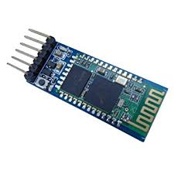

**Fig-6.3 Bluetooth Device**

Bluetooth is a packet-based protocol with a master/slave architecture. One master may communicate with up to seven slaves in a pico net. All devices share the master's clock. Packet exchange is based on the basic clock, defined by the master, which ticks at 312.5 µs intervals. Two clock ticks make up a slot of 625 µs, and two slots make up a slot pair of 1250 µs. In the simple case of single-slot packets the master transmits in even slots and receives in odd slots. The slave, conversely, receives in even slots and transmits in odd slots. Packets may be 1, 3 or 5 slots long, but in all cases the master's transmission begins in even slots and the slave's in odd slots.The above is valid for "classic" BT. Bluetooth Low Energy, introduced in the 4.0 specification, uses the same spectrum but somewhat differently; see Bluetooth low energy# Radio interface.

**6.2.1 COMMUNICATION AND CONNECTION:**

A master BR/EDR Bluetooth device can communicate with a maximum of seven devices in a piconet (an ad-hoc computer network using Bluetooth technology), though not all devices reach this maximum. The devices can switch roles, by agreement, and the slave can become the master (for example, a headset initiating a connection to a phone necessarily begins as master—as initiator of the connection—but may subsequently operate as slave).

Bluetooth Core Specification provides for the connection of two or more piconets to form a scatter net, in which certain devices simultaneously play the master role in one piconet and the slave role in another.

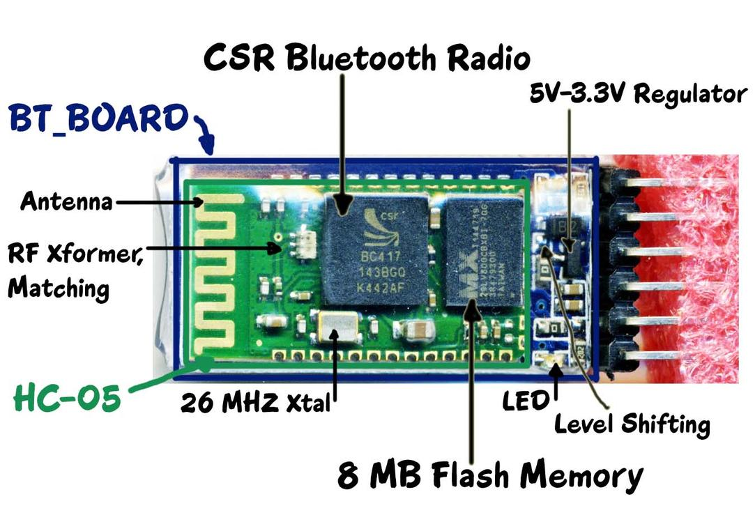

**Fig-6.4 Bluetooth Devices Parts**

At any given time, data can be transferred between the master and one other device (except for the little-used broadcast mode). The master chooses which slave device to address; typically, it switches rapidly from one device to another in a round-robin fashion. Since it is the master that chooses which slave to address, whereas a slave is (in theory) supposed to listen in each receive slot, being a master is a lighter burden than being a slave.

**CHAPTER-VII**

**OPERATION OF SOLAR GRASS CUTTER**

**7.1 INTRODUCTION:**

A Solar grass cutter is a machine that uses sliding blades to cut a lawn at an even length. Even more sophisticated devices are there in every field. Power consumption becomes essential for future. ϖThe solar grass cutter consists of the photovoltaic cell for the efficiency power from solar panel. The DC to DC buck boost converter helps to step up the DC voltage from the photovoltaic panel and store the DC voltage in a battery. It is an automated system for the purpose of grass cutting.

**7.2 METHODOLOGY:**

The Solar grass robot is made up of an DC motor, a battery, an alternator, three collapsible blades, and a link Mechanism. The power and charging system comprises of an alternator which charges the battery while in operation. The D.C. motor forms the heart of the machine and provides the driving force for the collapsible blades. This is achieved by the combined effect of mechanical action of the cutting blades and the forward thrust of the mower. The system is powered by an electrical switch which completes the circuit comprising the induction motor and the battery. The IR senor is finding the path to avoid the obstacles and machine damage. The shaft fitting mechanism with which the height of cut is altered.

**7.3 COMPONENTS USED:**

The main components of the solar powered grass cutter are

1. Solar panels
2. Batteries
3. Brush less DC motor
4. Solar charger
5. Blades
6. Bluetooth

**7.3.1 SOLAR PANEL:**

The solar panels are used to generate electric power. The photo- voltaic effect can be observed in nature in a variety of materials that have shown that the best performance in sunlight is the semiconductors as stated above. When photons from the sun are absorbed in a semiconductor, that create free electrons with higher energies than the created there must be an electric field to induce these higher energy electrons to flow out of the semi-conductor to do useful work.

**7.3.2 BATTERY:**

The batteries are used as a storage device for solar energy which can be further converted into electrical energy. Batteries can be in the interior of the lawn mower or on the outside Theory of DC motor speed control The speed controller works by varying the average voltage sent to the motor. It could do this by simply adjusting the voltage sent to the motor, but this is quite inefficient to do. A better way is to switch the motor's supply on and off very quickly. If the switching is fast enough, the motor doesn't notice it, it only notices the average effect.

**7.3.3 SOLAR CHARGER:**

The power charge regulator is also known as charge controller, voltage regulator, charge-discharge controller or charge-discharge and load controller. The regulator sits between the array of panels, the batteries, and the equipment or loads . Blades A blade is that portion of a tool, weapon, or machine with an edge that is designed to cut and/or puncture, stab, slash, chop, slice, thrust, or scrape surfaces or materials. A blade may be made from a flaking stone, such as flint, metal, ceramic, or other material.

**7.3.4 BLADES :**

A blade is that portion of a tool, weapon, or machine with an edge that is designed to cut and/or puncture, stab, slash, chop, slice, thrust, or scrape surfaces or materials. A blade may be made from a flaking stone, such as flint, metal, ceramic, or other material.

**7.3.5 BLUETOOTH:**

The Bluetooth module is used to control the solar based mower through the mobile phone.

**7.3.6 DC MOTOR:**

Rotation is achieved by the electrical motor which provides the required torque needed to drive the stainless steel blade which is coupled to the shaft and to the gears to the motor.

**7.4 DESIGN CONCEPTS:**

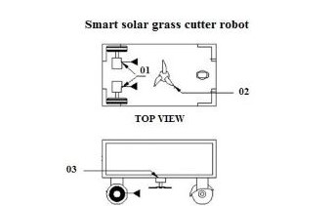

**Fig 7.1 Design Concept**

**7.5 OPERATION PRINCIPLE:**

The working principle of solar grass cutter is it has panels mounted in a particular arrangement at an in such a way that it can receive solar radiation with high intensity easily from the sun. These solar panels convert solar energy into electrical energy .This machine consists of the photovoltaic, dc to dc converter, motor, controller, linear blades , battery. It is an automated system for the purpose of grass cutting.

Electrical energy of the battery is converted to mechanical energy through a set of blades designed to achieve cutting operation. The electric circuit ensures power transfer from the battery to run the D.C. motor, whilst the solar panel power to continuously recharge the battery while in operation. The cutting blades tap power from the D.C motor.

When the power switch is on, the electrical energy from the battery powers the motor which in turn actuates the blades. The solar panel generates current to recharge the battery, thereby compensating for the battery discharge. The rotating blades continuously cut the grass as the mower is propelled forward and the cut grass. Height of cut is adjusted by means of the link mechanism via the lift rod.

**CHAPTER-VIII**

**ADVANTAGES AND DISADVANTAGES**

**8.1 ADVANTAGES:**

* Solar power as an energy source will address a number of issues that standard internal combustion engine mowers do not. An electric grass cutter with a solar charger will be easier to use. There is no messy dangerous gasoline to deal with Most importantly it eliminates the emissions of an internal combustion mower.
* Easy to move from one place to another place.
* Compact size and portable.
* Operating principle is simple.
* Non-skilled person also operate this machine.
* Small size and portable.
* Reduces manual labour.
* Solves the problem of manual labour shortage by autonomous operation.
* Use of solar power saves energy.
* Cost effective.
* Phone/pc controlled.

**8.2 DISADVANTAGES:**

* Large time required to remove the grass.
* Manually operated.
* Difficult to operate in rainy seasons.

**8.3APPLICATIONS**

1. For cricket ground.
2. The football ground.
3. All garden
4. All Playground

**CONCLUSION**

Robotics is very vast field which comes with different combinations of technology this will helps to reduce the human effort and gives maximum efficient output for the work, Nowadays lot of energy is wasted for mowing lawn in different areas of the world and also takes lots of human effort for the work. The main aim of this project is to make a solar powered automated robotic lawn mower system which will helps to mows the lawn in different design with lesser human effort. Advantages of this system are used components are of low cost so and in bulk production and adding of few more sensors doesn’t makes any difference. but the disadvantage is that sometimes response of the system is too slow so in real time high end DSP processors is recommended that can process much faster.

**REFERENCES**

[1] Int. Journal of Engineering Research and Applications ISSN : 2248-9622, Vol. 4, Issue 9( Version 3), September 2014, pp.10-21.

[2] Guo-shing Huang and Keng-Chih Lin proposed “ Intelligent auto saving energy robotic lawn mower”.IEEE transaction on robotics. Pg 4130 to 4136 In 2010.

[3] Junho Yang and Soon-Jo Chung proposed “vision-based localization and mapping for an autonomous mower ”. IEEE intelligent robots and systems(IROS) nov 3-7 tokyo, japan. In 2013.